Ideation Phase
Define the Problem Statements

Date | 16 March 2025
Team ID | SWTID1744544274
Project Name | Book-Store
Maximum Marks | 2 Marks

Customer Problem Statement :

Customer Profile:
- Target Audience:
Who is experiencing the problem? (e.g., Book buyers, book lovers, avid readers, online shoppers)
- Customer Needs:
What does the target audience need or desire? (e.g., A seamless online platform for browsing, purchasing, and managing books)

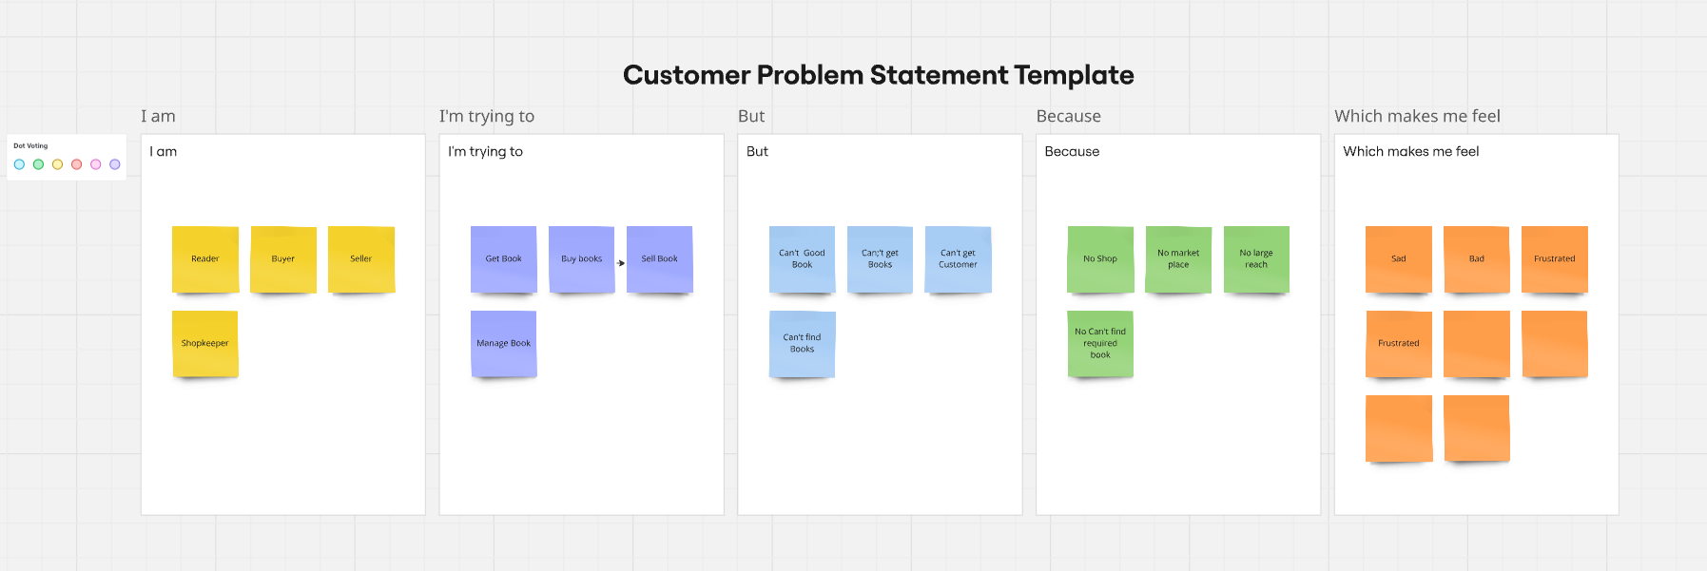

Problem Description:
- The Problem:
What is the primary problem the customer is facing?
(e.g., Customers find it difficult to browse and purchase books online due to complex user interfaces, lack of personalization, and absence of important features like wishlist or reviews.)
- Pain Points:
What specific challenges or frustrations are customers experiencing?
(e.g., Inconvenient navigation, slow website speed, no option to filter books by genre, no easy way to save favorite books, or insufficient payment options.)
- Consequences:
What happens if the problem is not addressed?
(e.g., Customers may abandon the website in favor of more user-friendly platforms, leading to a decrease in sales and customer retention.)

Desired Outcome:
- Solution Benefits:
What is the ideal solution the customer is looking for?
(e.g., A fast, responsive, and intuitive online bookstore where users can easily browse, save books to their wishlist, read reviews, make secure purchases, and have a personalized experience.)
- Customer Goals:
What does the customer want to achieve by using this solution?
(e.g., A seamless and enjoyable book shopping experience, the ability to track order history, and a personalized book recommendation system.)

Example Customer Problem Statement:
As an online book buyer, I want a user-friendly platform where I can easily browse books, read reviews, and make purchases, so that I can quickly find the books I’m interested in, save them for later, and check out securely without any hassle. Currently, many online bookstores lack personalized features such as a wishlist, reviews, and an easy navigation system, making the shopping experience tedious and frustrating.

